Signal generator realised with NE555 astable multivibrator

Petar Nikolić

Abstract - This project shows the realisation of a signal generator using NE555, LM2902 quad-operational amplifier and RC low pass filters.
.
I. Introduction

This signal generator circuit is consisted of 3 blocks that are used to generate and modify the signals. First, a NE555 oscillator generates a square and a triangle wave, then a square wave can be converted to a sine wave using RC filters. Sawtooth and impulse signals can also be generated.
By manually short-circuiting, the desired waveform can be shown on the output. Signal parameters are modified by the use of potentiometers. A practically realised circuit of this signal generator is shown in Fig. 1. This circuit was simulated in LT Spice simulator.

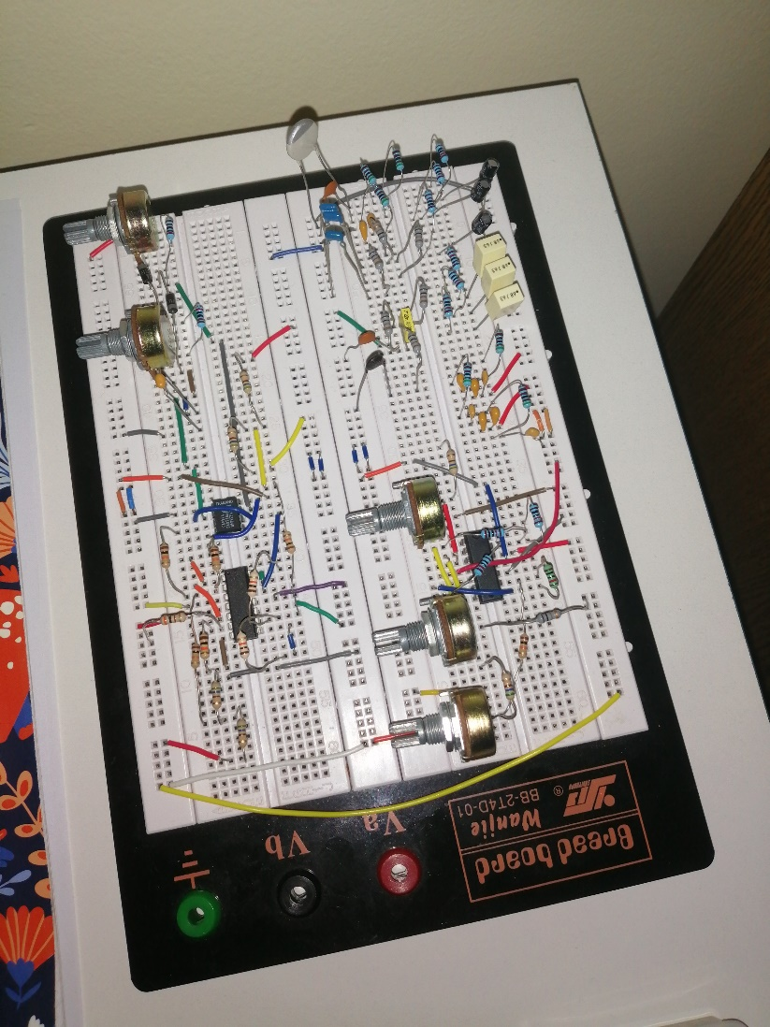

Fig. 1. Signal generator circuit realised on a breadboard

P. Nikolić is with the Department of Microelectronics, Faculty of Electronic Engineering, University of Niš, Aleksandra Medvedeva 14, 18000 Niš, Serbia, E-mail: nikolicpetar@elfak.rs
II. Description of function of signal generator blocks

A.First block

In this block the base square waveform is generated using NE555 in astable multivibrator configuration. The 1N4001 diodes are used so that the capacitor is charged and dicharged through a different potentiometer and resistor pair. This enables the manual control of duty cycle of the square wave and the symmetry for a triangular waveform by changing the value of potentiometers.
Trigger and threshold pins of NE555 are short-circuited and connected to the positive electrode of the capacitor, and with NE555’s internal structure in mind [1], this means that the capacitor charges to and when the voltage across the capacitor exceeds this value, that triggers the comparator and the SR latch is reset, which enables the capacitor to discharge to , and the cycle starts again.
The charging time of the capacitor is for the square wave, and discharging time is . First block is shown in Fig. 2. The voltage on the capacitor and on the ouput of NE555 is shown on Fig. 3.
The resistors that are in series with potentiometers have a function to limit the diode current, in case the potentiometers are set at their lowest resistance value. The capacitor value is 68nF and the resistance in series with it is in range from 2kΩ to 222kΩ for each resistor-potentiometer pair, and with those values the frequency range is calculated with Eq. 1:

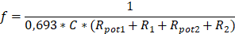 (1)

In the LT Spice simulator this frequency can vary from 5Hz to 20kHz, depending on the capacitor value, because at 20kHz great distortions are present in the generated waveform. However, when this schematic is realised with real components, the frequency range is narrower, due to the parasitic values that are present. For a 68nF capacitor frequency range goes from 50Hz to 5,3kHz, but because of the parasitic values that cause distortions at 4kHz, real frequency range goes from 50Hz to 4kHz. The duty cycle and symmetry have a range going from 0,9% to 99,1%. Duty cycle/symmetry formula is shown in Eq. 2:

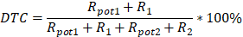 (2)

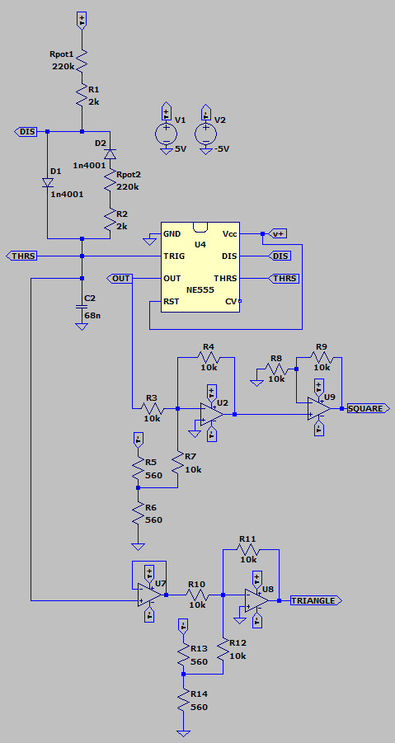

Fig. 2. First block (NE555 square/triangle wave oscillator)

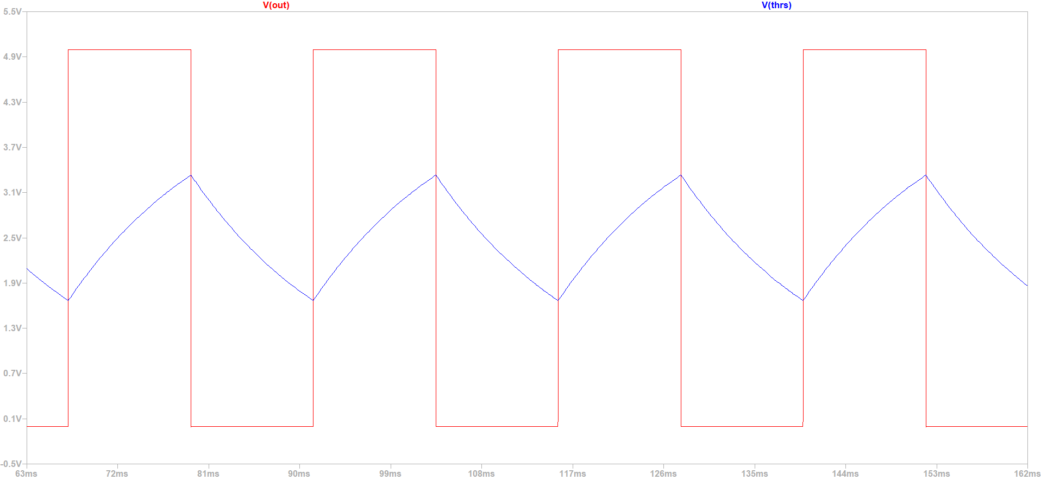

Fig. 3. Charging and disharging of the capacitor and square wave on the output of NE555

The output pin of NE555 generates the square wave, but it’s amplitude has a range that goes from 0V to the value of , because NE555 is single-supply. So LM2902 dual-supply circuit is applied to change that range to to [2]. With the first operational amplifier in inverting configuration, half of is added to the output signal of NE555. Then the square wave on the output of this operational amplifier has an amplitude range going from to . This square wave is passed to the non-inverting pin of the next op-amp which further amplifies the signal by A=2. So the final amplitude range for square wave is to .
Triangular waveform is present on the positive electrode of the capacitor, it’s shape presents the charging and discharging of the capacitor. This signal is passed to the input of voltage-buffer circuit, so that the next circuits don’t affect the NE555. In the next step, offset of is added to the signal. Final amplitude range for the triangular waveform is to .
These amplitude ranges are of fixed values on the output of the first block, but they can be modified when passed, by short-circuiting, to the third block, which function is to modify the amplitude and add an offset to the generated signal.
It is important to notice that square and triangular waveforms are both inverted once in this block. This is annuled with the summing amplifier circuit at the end of the third block.

B.Second block

This block contains the low-pass RC filter circuits which are the foundation for the forming of sinusoidal waveform. As input for these circuits, the square waveform generated in the previous block is being used. Depending on the frequency of the input signal, values of resistance and capacitance differ, so for the range from 50Hz to 4kHz, four different RC circuits are made. Each of these circuits have three low-pass filters that form the sinusoidal wave on the output. The second block is shown in Fig. 4.

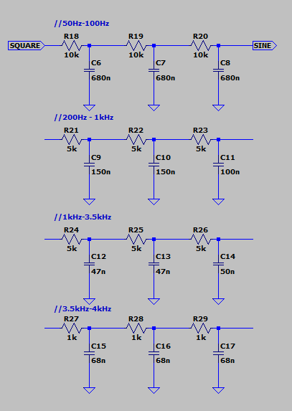

Fig. 4. RC filters used for the sine wave
The range of frequencies for each RC circuit are experimentally confirmed to be to , where is the corner-frequency of the base RC circuit. Formula for the corner-frequency is Eq. 3:

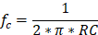 (3)

So for the first circuit 10kΩ resistors and 680nF capacitors are used to get the frequency range of 35Hz to 100Hz. The other three RC circuits have frequency ranges of: 200Hz to 1kHz, 1kHz to 3,5kHz and 3,5kHz to 4kHz.
Some approximations have been made when calculating these ranges.
As the frequency of the input square wave increases, the amplitude of sinusoidal wave decreases.
In conclusion, this block is being used only when the sinusoidal waveform is generated, for all the other waveforms, first block and the third block are the only ones being used.

C.Third block

Another LM2902 circuit is used in this block. As stated before, this block is used for signal modifications. By short-circuiting the waveform from previous blocks (square, triangular, sinusoidal, impulse, sawtooth or PWM), amplitude can be amplified or attenuated and positive or negative offset can be added to the waveform. Third block is shown in Fig. 5.

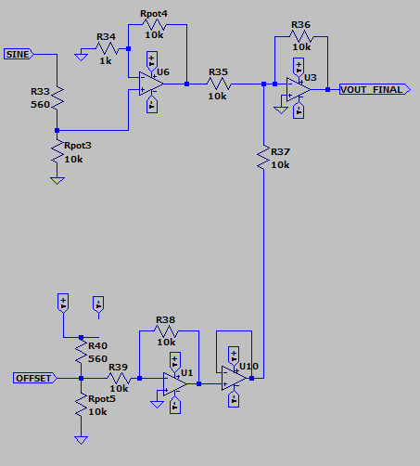

Fig. 5. Third block for signal modification

At first signal is passed to a voltage divider which has a function to attenuate the signal, this is mostly used for the square/impulse/PWM signals because of their starting amplitude range of to . For all the other signals starting amplitude range is lower. This voltage divider consists of a 560Ω resistor and a 10kΩ potentiometer.
This signal is amplified in the next step, op-amp in non-inverting configuration is used, with a 10kΩ potentiometer as a feedback resistor, and a 1kΩ resistor with one pin connected to inverting input and the other connected to the ground. This means that the amplification is in the range from 0 to 11.
To modify the offset value another voltage divider is used, identical to the one used for attenuation of the input waveform, with or chosen by short-circuiting. This offset is inverted once with an op-amp in inverting configuration. Then the signal is passed to a voltage-buffer for isolation of this circuit from the next one.
Amplified waveform signal and inverted offset signal are then passed to summing amplifier circuit which amplifies both of the signals by A = -1, so the sum of these voltages is present on the output. And the negative unity gain is used because both of the signals were inverted once, before being passed to this final circuit.
With all of the above taken into consideration, formulas for the offset and amplitude of the signal are, respectively, shown in Eq. 4 and Eq. 5:

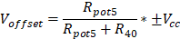 (4)

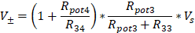 (5)

- potentiometer used for offset value modification (0-10kΩ);
- potentiometer used for amplitude amplification (0-10kΩ);
- potentiometer used for amplitude attenuation (0-10kΩ);
, = 560Ω, = 1kΩ;
- supply voltage;
- amplitude of the waveform on input of the third block.

III. Comparison of signals

In this chapter, signals that are being compared are results of LT Spice simulation and real signals that have been recorded on an oscilloscope.
First, we can compare the square signal at its lowest possible frequency. At the lowest frequency of 50Hz, potentiometers in the first block are both set to 210kΩ, close to their maximum value. Supply voltage is 10V. The signal from LT spice simulation and signal recorded on the oscilloscope, are displayed in Fig. 6 and 7, respectively. By comparing these signals, we can see that there are no significant differences at 50Hz, except that the amplitude of the signal on the oscilloscope is slightly below 10V.
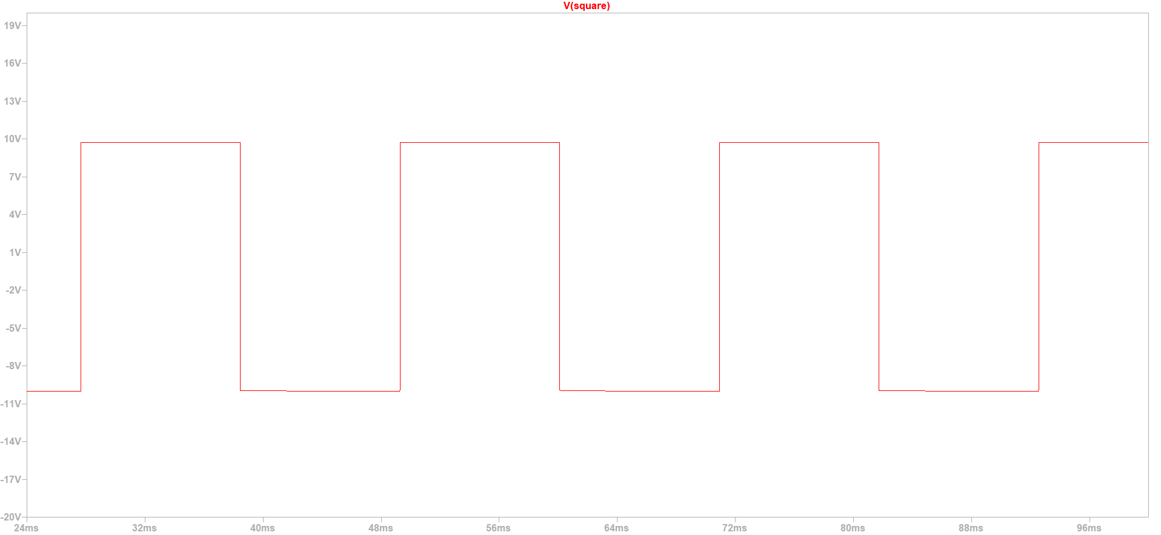

Fig. 6. LT Spice simulation for 50Hz square wave

Fig. 7. 50Hz square signal recorded on the oscilloscope

For the second comparison, a 4kHz square wave is generated. Potentiometers in the first block are set to 650Ω, close to their lowest value. Signals are displayed in Fig. 8 and in Fig. 9. On the signal from the oscilloscope we can see that there are distortions present due to the parasitic values of the wiring on the breadboard, so higher frequencies than 4kHz can’t be generated.

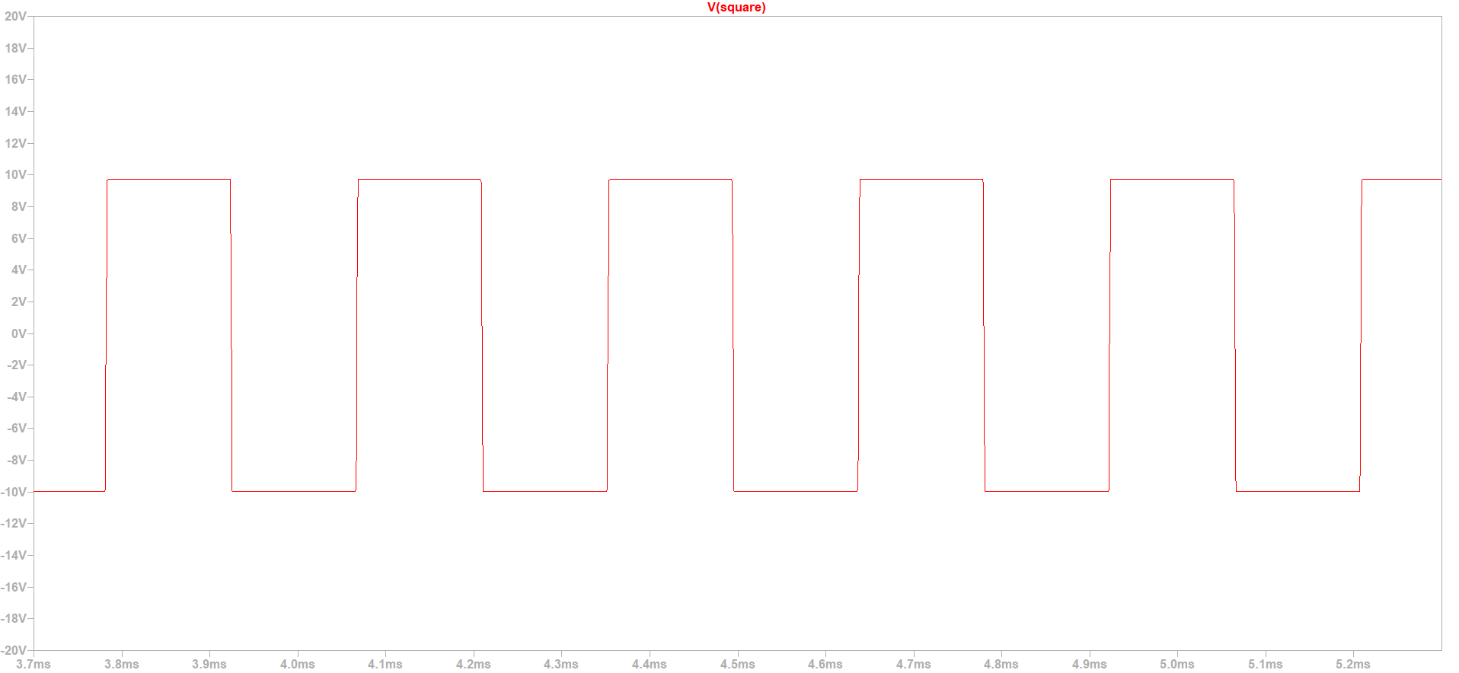

Fig. 8. LT Spice simulation for 4kHz square wave

Fig. 9. 4kHz square signal recorded on the oscilloscope
In Fig. 10. and Fig. 11. square, triangular and sine waves are shown, with the frequency set to 300Hz for all three signals. Sine wave is amplified in the third block and, only on the oscilloscope screen, it is streched out for better viewing. This shows that within the given range of 50Hz to 4kHz, signals are generated without distortions.

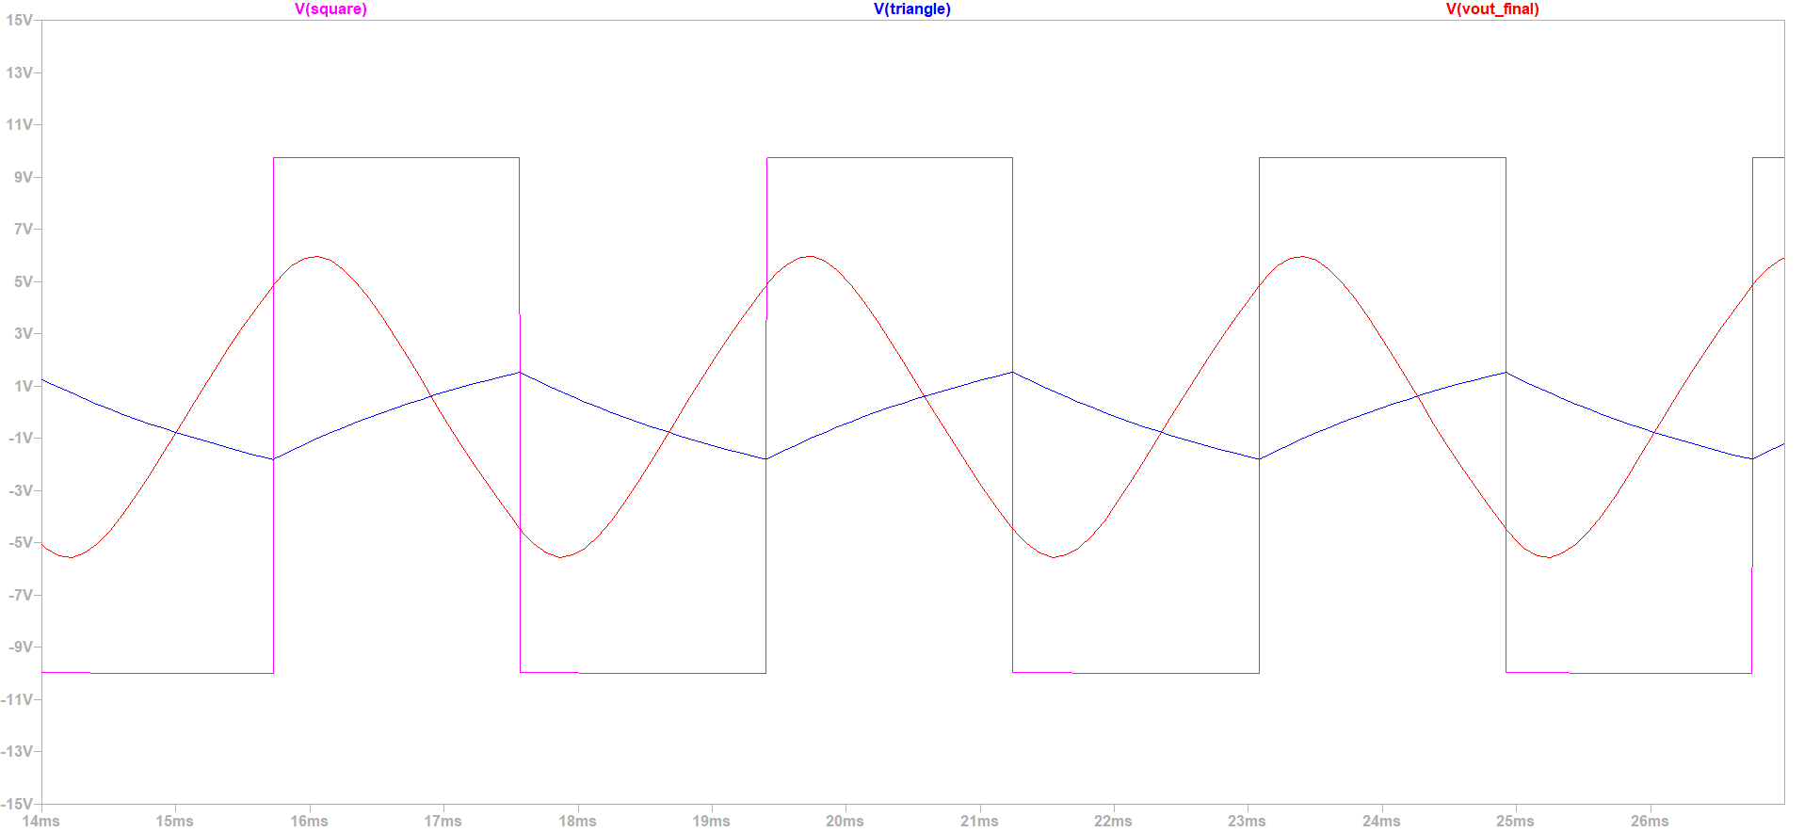

Fig. 10. LT Spice simulation for 300Hz square, triangle and sine wave

Fig. 11. 300Hz square, triangle and sine signals recorded on the oscilloscope

To see how signal parameters can be changed a sine wave is observed, with a frequency of 330Hz, supply voltage is 5V. So signals in Fig. 12. and 13. are on the output of the second RC filter (200Hz – 1kHz). In LT Spice amplitude is in range from 0.7V to -0.8V, and on the oscilloscope it is 0.4V to -0.8V.

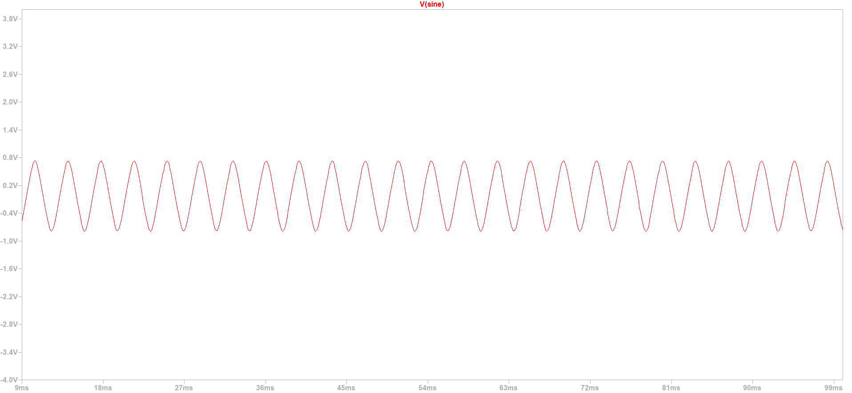

Fig. 12. LT Spice simulation for 330Hz unmodified sine wave

Fig. 13. 330Hz unmodified sine signal recorded on the oscilloscope

In Fig. 14. and 15. sine wave is amplified to it’s maximum possible amplitude range. On the oscilloscope amplitude range is -4V to 4V, and -4.6V to 5V in the simulation.

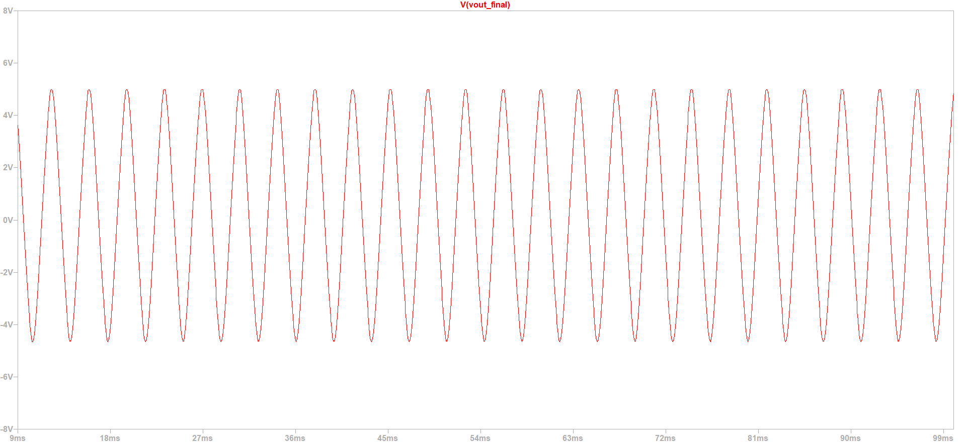

Fig. 14. LT Spice simulation for 330Hz amplified sine wave

Fig. 15. 330Hz amplified sine signal recorded on the oscilloscope

In the last comparison, in Fig. 17. and 18, an offset of +2V is added to the amplified sine signal. It is amplified by 4 in this case. On the oscilloscope amplitude range is 0 to 4V, and in LT Spice it is -0,7V to 5V.

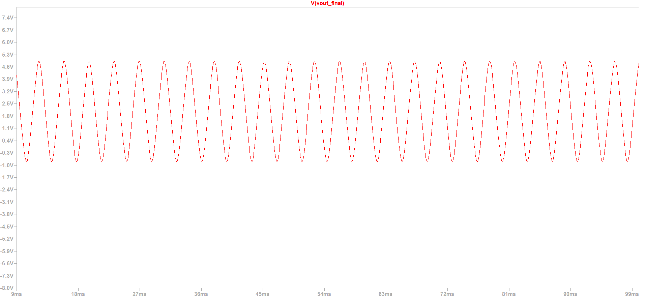

Fig. 17. LT Spice simulation for 330Hz sine wave with an offset

Fig. 18. 330Hz sine signal with an offset recorded on the oscilloscope

IV. Conclusion

In conclussion, this method for a signal generator has it’s advantages and disadvantages. Simple design and solid wave shape within the given range of frequencies are it’s advantage. It’s disadvantage is manual control of the generator by short-circuiting the correct parts of the circuit. So, for further upgrades, this problem could be solved by implementing a circuit with electrical switches (MOSFETs) and a microcontroller which would control those switches through a user defined program.

Acknowledgement

The author thanks m. eng. Nikola Mitrović for the practical help and suggestions in the making of this paper.

References

[1] NE555 datasheet
[2] LM2902 datasheet

